Project Design Phase-II
Data Flow Diagram & User Stories

Date | 08 september 2026
Team ID
Project Name | ServiceNow-Based Employee Laptop Request Application
Maximum Marks | 4 Marks

Data Flow Diagrams:
A Data Flow Diagram (DFD) is a traditional visual representation of the information flows within a system. A neat and clear DFD can depict the right amount of the system requirement graphically. It shows how data enters and leaves the system, what changes the information, and where data is stored.

Example: (Simplified)

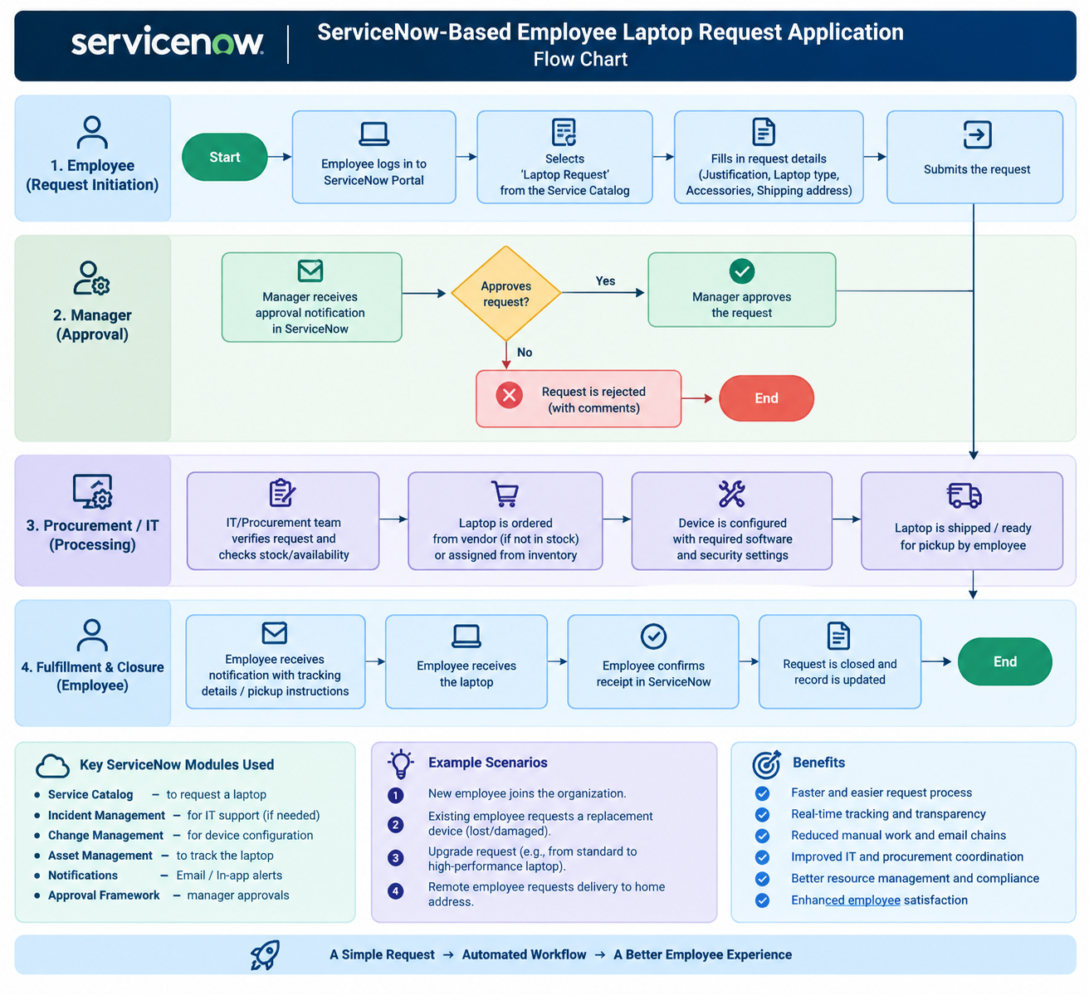
User Stories:
User Type | Functional Requirement (Epic) | User Story Number | User Story / Task | Acceptance Criteria | Priority | Release
Employee | Laptop Request | USN-1 | As an employee, I can access the ServiceNow portal to request a laptop. | I can access the laptop request form from the Service Catalog. | High | Sprint-1
 | Laptop Request | USN-2 | As an employee, I can select the required laptop type. | I can select an available laptop type from the provided options. | High | Sprint-1
 | Laptop Request | USN-3 | As an employee, I can enter my laptop request details. | I can provide required details such as laptop type, justification and accessories. | High | Sprint-1
 | Laptop Request | USN-4 | As an employee, I can submit the laptop request. | The request is successfully submitted and a request number is generated. | High | Sprint-1
 | Request Tracking | USN-5 | As an employee, I can view the status of my laptop request. | I can see whether the request is submitted, approved, rejected, or fulfilled. | High | Sprint-1
 | Notifications | USN-6 | As an employee, I can receive notifications about my request. | I receive notifications when the request status changes. | Medium | Sprint-2
 | Request History | USN-7 | As an employee, I can view my previous laptop requests. | I can access my submitted request history and details. | Medium | Sprint-2
Manager / Approver | Request Approval | USN-8 | As a manager, I can view laptop requests submitted by my employees. | I can access pending requests assigned to me for approval. | High | Sprint-1
 | Request Approval | USN-9 | As a manager, I can approve a laptop request. | The request status changes to approved and moves to the IT/fulfillment stage. | High | Sprint-1
 | Request Approval | USN-10 | As a manager, I can reject a laptop request with a reason. | The request is rejected and the employee is notified with the rejection reason. | High | Sprint-1
IT / Support Team | Request Processing | USN-11 | As an IT team member, I can view approved laptop requests. | I can see all approved requests assigned for IT processing. | High | Sprint-1
 | Inventory Management | USN-12 | As an IT team member, I can check laptop availability. | I can verify whether the requested laptop is available in inventory. | High | Sprint-1
 | Laptop Assignment | USN-13 | As an IT team member, I can assign a laptop to an employee. | The assigned laptop and asset details are recorded against the request. | High | Sprint-2
 | Configuration | USN-14 | As an IT team member, I can update the laptop configuration status. | The request reflects that the laptop has been configured and is ready. | Medium | Sprint-2
 | Fulfillment | USN-15 | As an IT team member, I can update the request when the laptop is shipped or ready for pickup. | The employee can see the fulfillment status in ServiceNow. | High | Sprint-2
Administrator | Request Management | USN-16 | As an administrator, I can view and manage all laptop requests. | I can search, view and update requests based on my permissions. | High | Sprint-1
 | Form Management | USN-17 | As an administrator, I can manage the laptop request form fields. | Required fields and available options can be maintained. | Medium | Sprint-2
 | Workflow Management | USN-18 | As an administrator, I can configure the laptop request approval workflow. | Requests follow the defined approval and fulfillment process. | High | Sprint-2
 | Notifications | USN-19 | As an administrator, I can configure request notifications. | Notifications are triggered for important request status changes. | Medium | Sprint-2
 | Reporting | USN-20 | As an administrator, I can view reports on laptop requests. | I can view request volume, status, approval and fulfillment information. | Medium | Sprint-3
Employee / IT Team | Request Closure | USN-21 | As a user, I can confirm that the laptop has been received. | The employee can confirm receipt and the request can proceed to closure. | Medium | Sprint-3
 | Request Closure | USN-22 | As an IT team member, I can close a completed laptop request. | The request is marked as closed after successful fulfillment. | High | Sprint-3

